|  |  |  |
| --- | --- | --- |
| **LAB221 Assignment** | **Type:** | **Long Assignment** |
| **Code:** | **J2.L.P0005** |
| **LOC:** | **300** |
| **Slot(s):** | **10** |

**Title: Happy Frog**

**Background**

Happy Frog game is a very small standalone game that imitates Flappy Bird one. Flappy Bird is a 2013 mobile game, developed by Vietnam-based developer Nguyễn Hà Đông (Dong Nguyen) and published by .GEARS Studios, a small, independent game developer also based in Vietnam. The game is a side-scroller where the player controls a bird, attempting to fly between rows of green pipes without coming into contact with them. The developer created the game over several days, using a bird protagonist which he had designed for a cancelled game in 2012.

The game was released in May 2013 but received a sudden rise in popularity in early 2014. It was criticized for its level of difficulty and alleged plagiarism in graphics and game mechanics, while other reviewers found it addictive. At the end of January 2014, it was the most downloaded free game in the iOS App Store. During this period, its developer claimed that Flappy Bird was earning $50,000 a day from in-app advertisements as well as sales.

Flappy Bird was removed from both Apple's App Store and Google Play by its creator on February 10, 2014, due to guilt over what he considered to be its addictive nature and overuse.

Source: https://en.wikipedia.org/wiki/Flappy_Bird

**Program Specifications**

**Rules**:

Happy Frog is a PC game featuring 2D graphics. The objective was to direct a frog, named "Happy Frog", who moves continuously to the right, between sets of pipes. If the player lets the frog touches the pipes, they lose. Frog briefly flaps upward each time that the player press up arrow key; if the key is not presses, frog falls because of gravity; each pair of pipes that he navigates between earns the player a single point, with medals awarded for the score at the end of the game. No medal is awarded to scores less than ten. A bronze medal is given to scores between ten and twenty. In order to receive the silver medal, the player must reach 20 points. The gold medal is given to those who score higher than thirty points. Players who achieve a score of forty or higher receive a platinum medal.

**Features:**

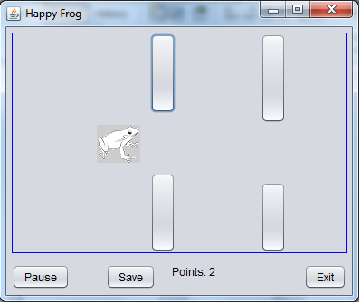

**Guidelines**

-Use JButtons to simulate pipes

-Use JLabel to draw frog

-Use the Java threads to make frog, pipes moving